ELEC 1100 Laboratory 3: Summary Sheet

Name: __________________________ Student ID:

Notes:
(1) Show demo to your TA for an attendance record; bonus mark will be given to groups who can complete all TA Checks in the first 2 hours of your enrolled lab session.
LA2 (Fri, before 15:30), LA3 (Mon, before 12:30), LA1 (Tue, before 15:30)
(2) Individually submit your completed lab summary sheet to Canvas (LA1/LA2/LA3) “Assignments” before the deadline.
LA2 (Fri, deadline 16:20), LA3 (Mon, deadline 13:20), LA1 (Tue, deadline 16:20)

Experimental Results and Analysis

Q1: Sketch what you see on the DSO (both CH1 & CH2 waves, including the voltage & time scales and zero references displayed on the screen).
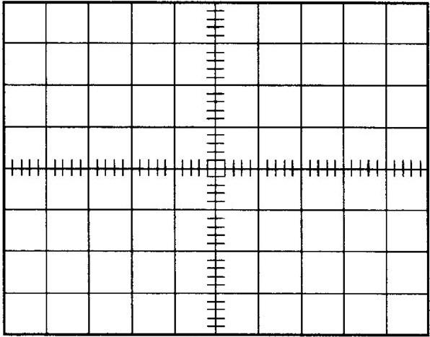
Notice: Do the sketching on the grid below by your hand, photos of DSO screen will NOT be accepted for grading.
CH1 5.00V CH2 5.00V M 500$μ$s

Q2: What is the difference between the two waveforms? Briefly explain your answer (Explain the feature of a diode).
One waveform is sine wave; another one only shows the positive side of sine wave. This phenomenon is due to the P-N junction of diode only allows one direction flow of current. Hence, when ac current is passed, only forward bias would be recorded.
Q3: Complete the table of experiment results (2-resistor circuit).
V_{in} (V) | 1 | 2 | 3 | 4 | 5 | 6 | 7 | 8
V_{Z} (V) | 0.752 | 1.531 | 2.267 | 3.061 | 3.835 | 4.569 | 5.337 | 6.09
V_{in} (V) | 9 | 10 | 11 | 12 | 13 | 14 | 15 | 16
V_{Z} (V) | 6.82 | 7.57 | 8.35 | 9.04 | 9.81 | 10.56 | 11.30 | 12.09

Q4: Complete the table of experiment results (Zener diode circuit).
V_{in} (V) | 1 | 2 | 3 | 4 | 5 | 6 | 7 | 8
V_{Z} (V) | 0.808 | 1.520 | 2.281 | 3.031 | 3.796 | 4.406 | 4.848 | 5.097
V_{in} (V) | 9 | 10 | 11 | 12 | 13 | 14 | 15 | 16
V_{Z} (V) | 5.219 | 5.295 | 5.310 | 5.343 | 5.367 | 5.386 | 5.400 | 5.414

Q5: Use the data you record in Q3 and Q4 to make a line chart of V_{Z} against V_{in} and fill in the space provided below.

Q6: From your record in Q4, determine the breakdown voltage (give a rough number) of the Zener diode.
Breakdown voltage = _____5.4V____________
Q7: What is the multimeter reading (V_{out}) displayed when V_{in} = 8V? _____5.008V_____
Q8: What is the multimeter reading (V_{out}) displayed when V_{in} = 12V? _______5.008V____
Q9: Use the results in Q7 and Q8, determine the line regulation of your LM7805 voltage regulator (Show your calculation).
$$Line regulation=\frac{ΔV_{O}}{ΔV_{I}}=\frac{5.008-5.008}{12-8}=\frac{0}{4}=0$$

